**ANNEX IX**

**Narrative reporting template for grantees**

1. **Basic Information**

* Name of the grantee: **Inclusion Africa**
* Project location: **Ghana and Benin**
* Project Name: **SPADRA Main Phase**
* Start/End Day of the activity: **01.07.2025 – 31.07.2025**.
* Total amount received: **N/A**

1. **Performance.   
   *Which activity you implemented?***

**GHANA**

**Activity 3.1.1:** A three-day workshop was organised to gather data on challenges and perspectives for ratification of ADP by the government of Ghana. The workshop was organised at the Windy Beach Hotel in Winneba 27-29th August 2025. It was attended by the following participants (*detailed list of participants is attached*):

* Organizations of Persons with Disabilities – 7
  + - Ghana Association of Persons with Albinism (GAPA)
    - Ghana Blind Union (GBU)
    - Ghana Federation of Disability Organizations (GFD)
    - Ghana National Association of the Deaf (GNAD)
    - Ghana Society of the Physically Disabled (GSPD)
    - Inclusion Ghana
    - Mental Health Society of Ghana (MEHSOG)
* Women-focused organization – 2
* Voices of Women and Children with Disabilities in Ghana (VOWAC Ghana)
* Pan-Africa Organization for Research and Protection of Violence on Women and Children (PAORP-VWC)
* Proposed mentee of community of practice – 1
* Young Woman with Bipolar Disorder
* Former Member of Parliament – 1
* Previous member of Disability Caucus in Parliament
* Director at the Commission for Human Rights in Ghana (CHRAJ).
* Sign language Interpreters – 2
* IA staff/rep – 3
* SPADRA Project Manager (Rapporteur)
* IA Finance Officer
* IA Board Chairman

The workshop comprised training, series of group work and plenary discussions. The facilitator trained participants on African Regional Human Rights Systems, with a focus on the ADP, its unique features and added value when compared with the CRPD, the reasons for which members states should ratify the ADP and the ratification process.

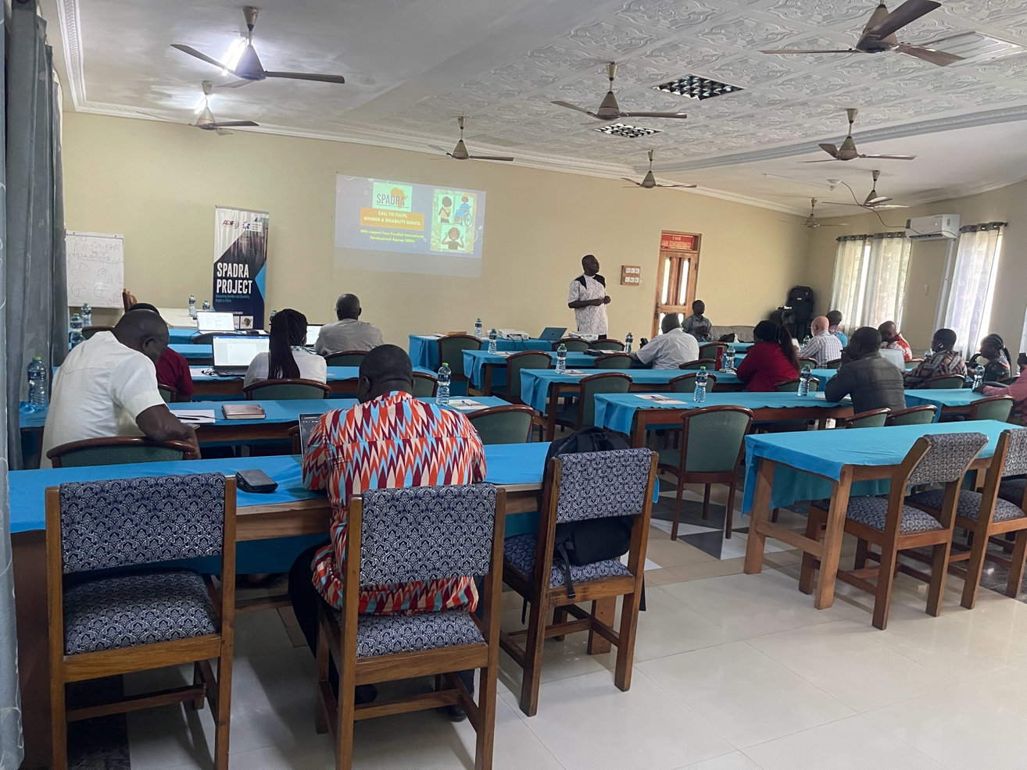Following the training in the first one and a half days of the workshop, the facilitator guided participants through series of group works to help solicit inputs to inform the planning of OPDs advocacy, lobbying and other engagements towards the ratification of the ADP by the government of Ghana. All the inputs made were captured by the SPADRA Project Manager, which have been compiled together and shared with the workshop facilitator. The final workshop report is being prepared by the facilitator and will be shared with the SPADRA Project Coordinator/ADF when ready.

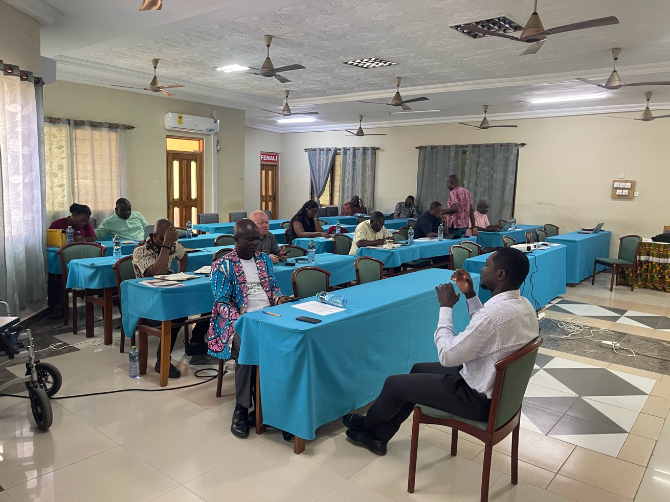

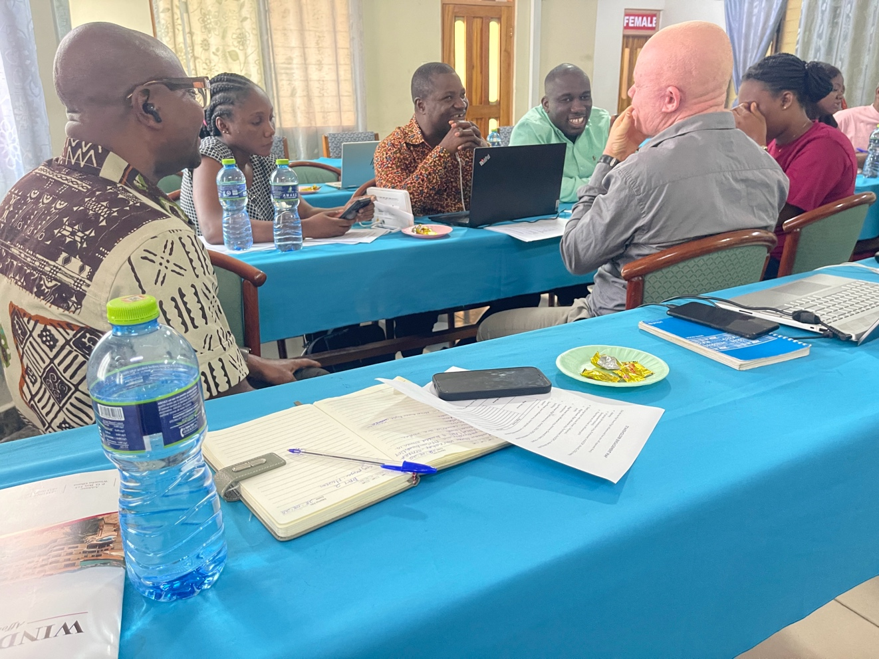

**Activity 4.1.1 Preparations**

A concept note and terms of reference for the workshop facilitator has been shared with the Project Coordinator for review and feedback. Contrary to having a consultant to develop the guidelines alone and then validate with a small number of OPD reps, the approach being pursued is to have more young women with disabilities to make inputs into the content of the guidelines so that it is more practical and reflective of the reality of exclusion that women and girls with disabilities face.

An advert for recruitment of expert in gender and disability inclusion to lead the development of the guidelines has been placed and shared on relevant platforms. The tentative dates for implementing this activity are 23-24 September 2025, using the same venue as activity 3.1.1.

**Meeting on Out-of-School Adolescent Girls Intervention by UNICEF**

The SPADRA Project Manager attended key stakeholders meeting to discuss baseline data gathered for the out-of-school adolescent girls programme being scaled up into 12 municipals and districts in Ghana. The intervention seeks to support economic empowerment of out-of-school adolescent girls aged 16-21 years of age who were victims of teenage pregnancy or child marriage as well as support poor girls who are not victims yet so as to prevent teenage pregnancy and child marriage amongst them.

Although the intervention is meant for any eligible out-of-school adolescent girl, I told the meeting that there should be conscious efforts by implementers to include out-of-school adolescent girls with disabilities because they are not likely to come out on their own to register for the intervention due to stigma or self-isolation. I also highlighted the fact that there are girls with disabilities who through sexual abuse suffered teenage pregnancy and do not have husbands to support them take care of their children. They need the skills training for economic empowerment that the UNICEF intervention offers.

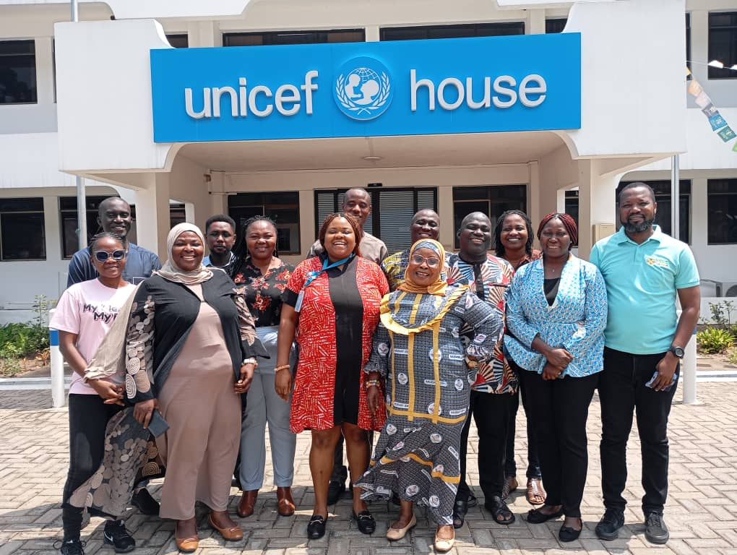

**BENIN**

**Activity 2.2.1:** Follow-up on previous correspondence by visit to offices of UNICEF, Plan International Benin, WILDAF Benin and the National Women's Institute to get appointment for meeting. The organizations promised to call to communicate the dates of the appointment.

**Preparations for Activities 3.1.1 and 4.1.1:** Prepared concept notes and budgets for both workshops, engaged some hotels for quotations to select venue for workshops and started the process to contract facilitator for each workshop. The activity 3.1.1 workshop is planned for 24-26 September 2025, while the workshop for activity 4.1.1 is planned for 2-3 October 2025.

***Which were the output/results of your activity?******Please attach the deliverables produced (i.e. links to reports, training tools, research findings, workshop report with full participant lists including disaggregated data[1]).***

**GHANA**

The following document are attached to this report:

* + List of participants of Activity 3.1.1 workshop

**How the activity contributed to achieve the objective of your project?**

**GHANA**

Activity 3.1.1 works towards a strong promotion of rights of women and girls with disabilities through the government’s commitment to the provisions of the ADP which is more reflective of abuse of rights that women and girls in Africa suffer. The workshop contributes to advocacy and lobbying efforts that will get the government to ratify the ADP and become bound by its provisions.

**BENIN**

These activities contribute directly to achieving the strategic objective of the SPADRA project.

1. **Adaptations**.   
   **Describe any challenges, delays, changes or risk in activity implementation** **that might have affected the achievement of your objective**.

**What was done to address these challenges and mitigate the effect?**

Not applicable.

1. **Participation & intersectionality**:   
   **How many people took part and/or were targeted by the activity? (Please disaggregated by age, gender, type of impairment, indigenous status).   
   Please describe measures taken to ensure inclusion of women, children, older persons, indigenous persons with disabilities and other underrepresented groups[2] as relevant.**

**GHANA**

There were 18 direct participants and assistants, comprised of 14 males and 4 females.

There were 4 drivers of officials who were all males.

**BENIN**

Not applicable.

1. **Lessons Learned.   
   What are the main lessons learned (programmatic, technical or operational) from the project implementation?   
   In light of these, would you have done something differently?   
   Please share any highlight or story that shows how this project is making change.[3]**

**GHANA**

Very strong advocacy and lobbying efforts, backed by substantial funding for stakeholder engagements will be required to push for the government of Ghana to ratify the ADP.

1. **Benefits of the project for your organisation**.   
   Please explain how this microgrant project supports your organizational capacity.

**GHANA**

Provided IA SPADRA Project Manager with knowledge on African human rights mechanisms, which will be useful throughout the project cycle.

1. **Please Note:** A full **participant list** must be submitted for any IDA funded events (workshops, trainings, meeting, etc.), both virtual and in person. Please ensure to include the following for each participant: First Name; Family Name; town and country of origin; disability type; Organization Name; Gender, Role at Event (Participant, facilitator, support person,iv etc.); age (can be a range, or mark if under 35 as youth); identify is a person is considered to be "underrepresented" including if they are an indigenous person;  contact info if applicable (email or phone number).
2. IDA understands the term “under-represented groups” to be those among persons with disabilities who enjoy less visibility in decision making processes. The disability movement, like other social movements, is not homogenous. There are some groups that have traditionally been less included in participatory processes, or harder to reach, or face higher barriers to participation such as: persons who are deafblind, persons with intellectual disabilities, persons with psychosocial disabilities, persons with autism or deaf people. It can also include those who may be less engaged in decision making such as women, children, older people and indigenous persons, as well as people from diverse faith, ethnicity, caste, class, sexual orientation or gender identity minorities. This understanding may differ in different countries, culture and contexts.
3. If you are sharing pictures/videos or names of individuals, please make sure you are granted their permissions.