**THE DISABILITY MANIFESTO**

**Agenda for an Inclusive Society for all**

**Persons with Disabilities**

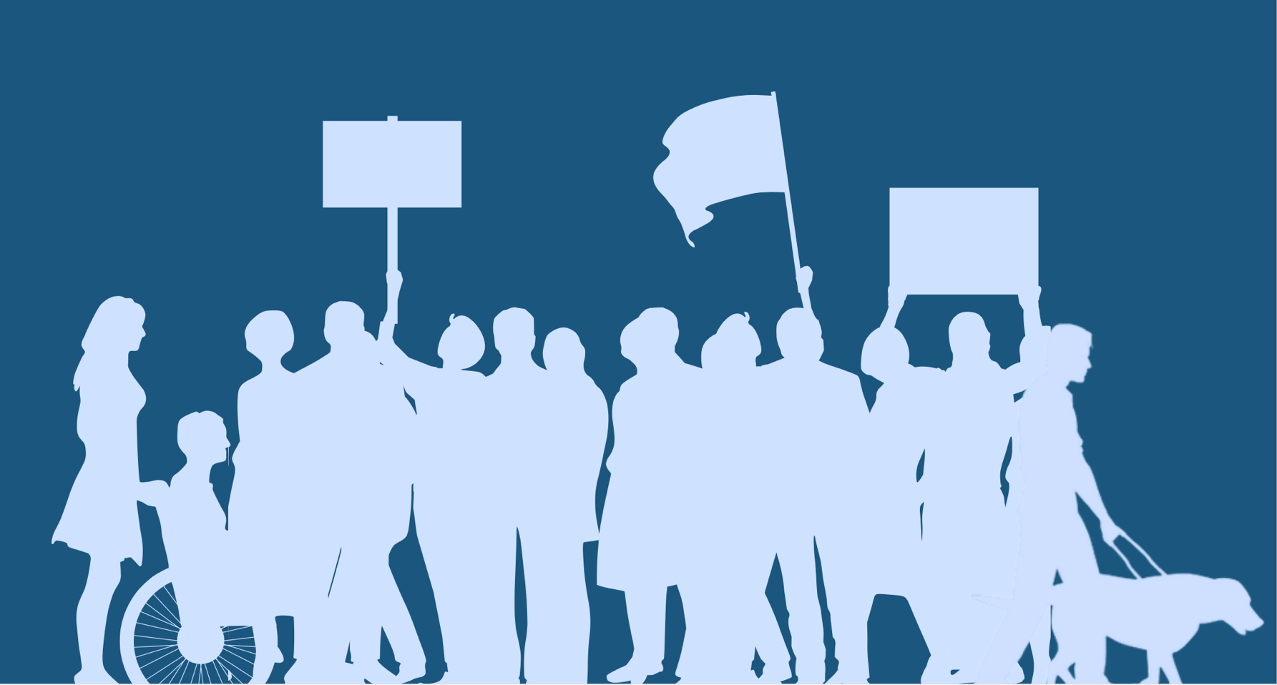

**EXECUTIVE SUMMARY**

Over the years, political parties have often not involved organizations of persons with disabilities in the development of their manifestoes, which mostly resulted in limited consideration for disability issues in their manifestoes. With the 2024 elections approaching, political parties must give due attention to the concerns and aspirations of this marginalized segment of society.

To promote the inclusion of disability issues in the manifestoes of the various political parties in Ghana, the Advocacy Committee of the Ghana Federation of Disability Organizations (GFD) has spearheaded the development of a Disability Manifesto for the 2024 elections. The manifesto will serve as a roadmap to guide policymakers and political leaders in formulating inclusive policies and implementing effective measures to ensure the full participation and empowerment of persons with disabilities in all aspects of Ghanaian society.

This manifesto outlines the key priorities for persons with disabilities to be fulfilled, in full alignment with the United Nations Convention on the Rights of Persons with Disabilities (CRPD), which Ghana ratified in 2012, as well as the Sustainable Development Goals (SDGs), and with the motto of the disability movement: “Nothing about us without us”. The key areas of concern include but not limited to legal protection, local governance, equal educational opportunities, health and well-being, economic empowerment, access to justice, housing, transportation, social protection and welfare, political and public life participation, data, accessibility issues, and women representation and participation. By addressing these domains comprehensively, the GFD aims to foster an inclusive society that upholds the rights and dignity of persons with disabilities, enabling them to thrive and contribute meaningfully to Ghana's development.

In the domain of health, the manifesto calls for improved access to quality healthcare services that are inclusive, affordable, and responsive to the specific needs of persons with disabilities. It highlights the importance of promoting preventive measures, early interventions, and rehabilitation services to enhance the overall well-being and quality of life for persons with disabilities.

Education is another critical area of focus in the manifesto. We call on all political parties to commit to increasing, long-term funding responding to the needs of learners with disabilities in inclusive and equitable educational opportunities at all levels, from early childhood to tertiary education. We advocate for accessible physical infrastructure, inclusive curricula, and the provision of necessary support services to ensure that persons with disabilities can access quality education on an equal basis with their peers without disabilities.

Economic empowerment is a key driver of social inclusion, and the manifesto highlights the importance of creating an enabling environment that promotes employment opportunities, vocational training, and entrepreneurship for persons with disabilities. We call on political parties to commit to guaranteeing the removal of barriers to employment, the promotion of inclusive workplaces, and the provision of reasonable accommodations and affirmative measures to facilitate the active participation of persons with disabilities in the labour market.

We also call on all political parties to recognize that political participation is a fundamental right for all including persons with disabilities. Through this manifesto, we urge political parties to adopt inclusive practices and to ensure that persons with disabilities can fully participate in the political process, both as voters and as candidates. The manifesto emphasizes the importance of removing barriers to political participation, such as inaccessible polling stations and discriminatory practices while fostering an inclusive political culture that values the contributions and perspectives of persons with disabilities.

Lastly, the manifesto recognizes the importance of social protection measures to safeguard the rights and well-being of persons with disabilities. It advocates for the establishment of comprehensive social protection programmes that provide financial support, healthcare, and other essential services to persons with disabilities, families affected by disability, and caregivers of persons with disabilities.

The GFD's Disability Manifesto represents a collective effort to address the challenges faced by persons with disabilities in Ghana and to chart a path toward greater inclusion and empowerment. By embracing the principles and recommendations outlined in this manifesto, political parties have the opportunity to demonstrate their commitment to disability rights and contribute to the creation of an inclusive society.

**BACKGROUND**

In Ghana, the challenges faced by persons with disabilities are pervasive and marked by various forms of inequalities, discrimination, and exclusion. Despite the country having a disability prevalence rate of 8%, equivalent to approximately 2.4 million people[1], the effective implementation of disability-inclusive policies and programmes remains inadequate. Consequently, individuals with disabilities continue to encounter significant barriers in accessing essential services such as education, healthcare, employment, and social support, resulting in many of them living in poverty and facing limited opportunities for economic empowerment. Furthermore, the lack of comprehensive disability-specific data and research compounds the issue, making it difficult to formulate evidence-based policies and programmes that effectively address the unique needs and challenges faced by persons with disabilities in Ghana.

The prevailing conditions faced by persons with disabilities are deeply rooted in various interconnected challenges. Negative social attitudes towards disability, coupled with inaccessible infrastructure, hinder the full participation of persons with disabilities in social, economic, and political processes. Limited opportunities for education and employment further exacerbate their exclusion from mainstream society. The abuse of the rights of persons with disabilities is another grave concern, arising from the absence of disability-friendly services and the insensitivity of duty-bearers towards their issues. Stigmatization persists, and the lack of complaint mechanisms hinders their ability to demand the fulfilment of their rights. Inadequate implementation of disability laws, as well as weaknesses in existing laws, contribute to systemic discrimination against persons with disabilities.

Over the years, political parties have often not involved organizations of persons with disabilities in the development of their manifestoes, which mostly resulted in limited consideration for disability issues. At the same time, ‘‘we often have little or no control over what is being done ‘to us’ ‘for us’ or ‘on our behalf.’’ As a result of this, there is a gap between what many politicians think persons with disabilities need and what we actually need. As the 2024 elections loom on the horizon, it is crucial that political parties give due attention and commit to the concerns and aspirations of persons with disabilities. To do this, the Advocacy Committee of the Ghana Federation of Disability Organizations (GFD) has spearheaded the development of this Disability Manifesto.

The manifesto outlines the key priorities for persons with disabilities to be fulfilled, in full alignment with the United Nations Convention on the Rights of Persons with Disabilities (CRPD), which Ghana ratified in 2012, as well as the sustainable development goals (SDGs), and with the motto of the disability movement: “Nothing about us without us”. The key areas of concern include but not limited to legal protection; local governance; equal education opportunities; health and well-being; economic empowerment; access to justice; housing; transportation; social protection and welfare; political participation and public life; and data. Some cross-cutting areas were also identified including accessibility to infrastructure and public places; women with disabilities representation and participation; and access to information and technology. By addressing these domains comprehensively, Ghana will foster an inclusive society that upholds the rights and dignity of persons with disabilities, enabling them to thrive and contribute meaningfully to Ghana's development.

**CONSULTATIVE PROCESS**

This Manifesto was arrived at through a nationwide process of consultation within the Ghana Federation of Disability Organizations and its members, as well as its regional branches. The Manifesto represents a collective effort to address the challenges faced by persons with disabilities in Ghana and to chart a path toward greater inclusion and empowerment.

Ghana Federation of Disability Organisations (GFD), formerly known as Ghana Federation of the Disabled, was established in 1987 as a national umbrella of organisations of persons with disabilities to provide a unified front in influencing national policies and promoting the participation of all persons with disabilities in society at all levels. The Federation's current full members are the Ghana Blind Union, Ghana Society of the Physically Disabled, Ghana National Association of the Deaf, Mental Health Society of Ghana, Inclusion Ghana, Ghana Association of Persons with Albinism, Share Care Ghana, Ghana Stammering Association and Burn Survivors Foundation. The affiliate members are the Centre of Employment of Persons with Disabilities, Special Mothers Project and Disability not Inability. Apart from these member organisations, GFD also works with some minority groups of persons with disabilities including Little people, persons with deafblindness, survivors of leprosy and survivors of stroke. GFD has branches in all 16 administrative regions and in 250 districts of Ghana.

**DEFINITIONS**

For the purposes of this Manifesto:

***Communication*** includes languages, display of text, Braille, tactile communication, large print, accessible multimedia as well as written, audio, plain-language, human-reader and augmentative and alternative modes, means and formats of communication, including accessible information and communication technology.

***Discrimination on the basis of disability*** means any distinction, exclusion or restriction on the basis of disability which has the purpose or effect of impairing or nullifying the recognition, enjoyment or exercise, on an equal basis with others, of all human and people’s in the political, economic, social, cultural, civil or any other field. It includes all forms of discrimination, including denial of reasonable accommodation.

***Persons with disabilities*** include those who have physical, mental, psychosocial, intellectual, neurological, developmental, or other sensory impairments which in interaction with environmental, attitudinal, or other barriers hinder their full and effective participation in society on an equal basis with others.

***Reasonable accommodation*** means necessary and appropriate modification and adjustments where needed in a particular case, to ensure to persons with disabilities the enjoyment or exercise on an equal basis with others of all human and people's rights.

***Universal design*** means the design of products, environments, programmes and services to be usable by all people, to the greatest extent possible, without the need for adaptation or specialized design, and shall not exclude assistive devices for particular groups of persons with disabilities where this is needed.

**LIST OF ISSUES AND PROPOSED ACTION TO ADDRESS CHALLENGES**

**LEGAL PROTECTION**

Ensuring equal rights for persons with disabilities, on equal terms with others in society is crucial for maximizing economic participation, fostering social inclusion, ensuring safety, and upholding equality. While Ghana’s Disability Act 715 and Article 29 of the 1992 constitution prohibit discrimination against persons with disabilities, instances abound of discrimination persisting in the daily lives of persons with disabilities. We urge all political parties to:

* Ratify all international and regional treaties relating to persons with disabilities and put in place systems for their implementation, monitoring and reporting.
* Enforce international and regional treaties such as the CRPD and the African Disability Protocol (ADP).
* Re-enact the Disability Act to align with the CRPD and ADP and put systems in place for its implementation, monitoring and reporting.
* Commit to reviewing existing laws to ensure they are in line with international standards and treaties on disability rights.
* Enhance policies, processes, and programmes to offer more effective responses to persons with disabilities who have experienced trauma.
* Develop policies, processes, and programmes that champion gender equality and prevent violence against groups at heightened risk, particularly women and children.

**LOCAL GOVERNANCE**

* Promote the inclusion of persons with disabilities in local decision-making processes and community development initiatives.
* Allocate resources for the implementation of disability-inclusive programmes and services at the grassroots level.
* Strengthen the capacity of local government structures to address the needs and concerns of persons with disabilities in their communities.
* Promote the active participation of persons with disabilities in local governance and decision-making processes by giving them a quota of appointments at the local level.
* Appoint disability inclusion advisors in all the Metropolitan, Municipal and District Assemblies (MMDAs)
* Mainstream disability issues in all programmes and projects of the MMDAs and ensure all budgets generated at the MMDAs are disability-inclusive.

**EQUAL EDUCATIONAL OPPORTUNITIES**

Facilitating access to both formal and informal education creates avenues for employment, financial independence, and enriched lives. Increased support is necessary to prepare learners with disabilities for school and to guide them throughout their educational journeys. We urge all political parties to:

* Ensure that all learners with disabilities can enjoy their right to quality inclusive education with personalized support in the general education system and through accessible online learning.
* Invest in inclusive education programmes that cater to the diverse learning needs of persons with disabilities, ensuring access to quality education from early childhood to tertiary levels.
* Provide scholarships, grants, and incentives to encourage learners with disabilities to pursue higher education and vocational training.
* Train teachers and education professionals on inclusive teaching methodologies and support systems for learners with disabilities.
* Invest in inclusive classrooms equipped with assistive technologies, trained educators, and supportive resources to accommodate diverse learning needs.
* Educational institutions must promote anti-discrimination policies and foster environments that celebrate diversity and encourage participation from learners with disabilities.
* Implement the reviewed inclusive education policy and allocate adequate resources for the effective implementation and monitoring of the inclusive education policy.
* Provide specialized training and resources for teachers to effectively cater for the needs of learners with disabilities.
* Invest in accessible infrastructure and assistive technologies within educational institutions.
* Ensure inclusive education for learners with disabilities by improving accessibility, providing assistive devices, and training teachers on inclusive teaching practices.
* Formulate and implement policies to promote inclusive higher education and vocational training opportunities for persons with disabilities.

**HEALTH AND WELL-BEING**

Persons with disabilities, especially persons with intellectual and developmental disabilities, and mental health conditions, experience significant and persistent health inequalities and are likely to die younger than other people. They are also much less likely to receive health checks and other routine healthcare treatment. Despite a commitment by the Government to make improvements to the provision of health care services including mental health services, considerable shortcomings remain. We call on all political parties to commit to:

* Ensuring access to comprehensive disability-friendly healthcare services, including sexual and reproductive health services, rehabilitation, and mental health services for persons with disabilities.
* Providing training for healthcare providers on the specific health needs and rights of persons with disabilities, including maternal and child health.
* Combating stigma and discrimination against persons with disabilities within the health care system through awareness campaigns and advocacy initiatives.
* Ensuring that healthcare facilities are fully accessible and well-equipped to cater for the diverse needs of persons with disabilities.
* Training healthcare professionals to provide inclusive and therapeutic care to individuals with disabilities.
* The expansion of healthcare coverage, specialized treatments, and rehabilitation services should be tailored to individual needs.
* Prioritizing disability-inclusive policies, investing in accessible healthcare facilities, and promoting preventive care strategies to address the unique health challenges faced by persons with disabilities.
* Strengthening preventive healthcare measures and ensuring equal access to healthcare information for persons with disabilities.
* Including essential drugs in the National Health Insurance Scheme (NHIS) drug list for persons with disabilities.
* Extending the NHIS coverage to include needed services for persons with disabilities such as physiotherapy, speech therapy, etc.
* Expanding visibility and health services in support of persons with disability in hard-to-reach areas.
* Incorporate individuals with disabilities into disaster preparedness, risk management plans, and public emergency responses, ensuring inclusive measures that support both their physical and mental health and well-being.

**ECONOMIC EMPOWERMENT**

Persons with disabilities face significant barriers when accessing employment (where employment is possible) and these have been exacerbated by the economic impact of COVID-19. While this manifesto looks at mitigating these immediate impacts, it also focuses on developing much-needed long-term, sustainable economic solutions to the specific barriers that persons with disabilities experience. We call on political parties to commit to guaranteeing:

* Support for persons with disabilities to maintain a job by funding training through both a “Train and Place” model, preparing persons with disabilities for the expectations of their role before they begin working, as well as a “Place and Train” model, in which training happens on site after the person has started their new role. Promote these among young people with disabilities.
* Funding for training programmes for young people with disabilities to facilitate their transition to the open labour market and abolish unpaid or underpaid traineeships and work placements. Focus particularly on vocational training, digital skills training, professional re-qualification, skills accreditation, career guidance and support.
* Comprehensive and flexible social security systems in which persons with disabilities can maintain disability-related support when accessing paid work and after retirement. Such systems will boost the participation of inactive persons with disabilities in the open labour market, offer sufficient levels of support to persons with disabilities, reduce the risk of poverty and social exclusion, and tackle the dangers faced by the cost-of-living crisis.
* Adoption and implementation of an employment equity policy to promote inclusive employment practices and create job opportunities for persons with disabilities in both the public and private sectors.
* Creation of incentives for businesses to hire individuals with disabilities and ensure inclusive employment practices including workplace accessibility.
* Development and implementation of disability-friendly entrepreneurship programmes and provide financial support to encourage the establishment of businesses owned by persons with disabilities.
* Provision of financial literacy training, access to microfinance, and business development support services to empower entrepreneurs with disabilities economically.
* Promotion of the inclusion of women with disabilities in economic policies, programmes, and initiatives aimed at poverty reduction and sustainable development.

**ACCESS TO JUSTICE**

Effective access to justice is among the essential ingredients of sustainable development and eradication of poverty. Access to justice, as a fundamental right in itself and as a precondition of the enjoyment of all other rights, is especially crucial for persons with disabilities and provides a unique tool to counter discrimination (and often disrespect, lack of dignity or even violence) that they face. Paradoxically, however, those who need effective access to justice most are the ones most frequently encountering barriers to it. We urge political parties to:

* Improve the responsiveness of the criminal justice system to the intricate needs and vulnerabilities of persons with disabilities.
* Ensure there are administrative and legal measures to remove physical, communication, and procedural barriers within the legal system.
* Make provision of procedural and age-appropriate accommodations for persons with disabilities, to facilitate their effective role as direct and indirect participants, including as witnesses, in all legal proceedings, including at investigative and other preliminary stages.
* Promote appropriate training for those working in the field of administration of justice, including judges, lawyers, social welfare officers, police and prison staff.
* Strengthen legal aid services and mechanisms for reporting and addressing cases of violence, abuse, and discrimination against persons with disabilities.
* Enforce laws and policies that protect the rights of persons with disabilities, including measures to prevent and respond to gender-based violence.

**HOUSING**

An inclusive Ghana should be characterized by inclusive, accessible, and well-designed homes and communities where persons with disabilities can live with dignity and full participation. Securing suitable housing and fostering an accessible, inclusive community plays a pivotal role in the daily lives, professional engagements, and social interactions of persons with disabilities. We seek the support of political parties to:

* Invest in the construction of affordable and adaptable housing units that meet the diverse needs of persons with disabilities.
* Develop and implement policies/programmes to ensure the availability of accessible and affordable housing options for persons with disabilities.
* Put measures in place to ensure compliance with the national building code and the national accessibility standards.
* Provide financial support and incentives to encourage the construction of accessible housing and the modification of existing homes for persons with disabilities.

**TRANSPORTATION**

In Ghana, a large proportion of urban and rural transport systems remain inaccessible to persons with disabilities. Mobility constraints are a serious impediment to disability-inclusive development, as they exacerbate the personal, economic, and social isolation of persons with disabilities. This has a negative impact on all aspects of daily life, including participation in education or training and employment. This restricts choice and life opportunities, and it is bad news for the economy as persons with disabilities are unable to play their part as full and active citizens. To break this cycle, the Ghana Federation of Disability organisation requests all political parties to:

* Commit to an urgent review of the effectiveness of legislation and public initiatives aimed at improving access to transport (including bus, rail, taxi and transport by air and sea) for persons with disabilities.
* Adopt legislative measures for air travel to avoid situations such as denial of boarding and lack of quality assistance in airports.
* Ensure equal access for persons with disabilities to individual transportation means (e.g., to obtain driving licenses and adapted cars).
* Improve public transportation infrastructure to make it accessible to persons with disabilities.
* Provide subsidies for accessible transportation services and ensure the availability of trained staff to assist passengers with disabilities.
* Develop inclusive transportation policies that consider the diverse mobility needs of persons with disabilities.

**SOCIAL PROTECTION AND WELFARE**

There is increasing evidence confirming that persons with disabilities are more exposed to the risk of poverty due to barriers in accessing employment, education and health care as well as disability-related costs and lack of access to support services. It is also widely acknowledged that social protection is critical to support the inclusion of persons with disabilities. Despite these acknowledgements, the majority of persons with disabilities do not enjoy social protection coverage and adequate benefits. The development of social protection systems needs to support the full and effective participation and inclusion of persons with disabilities. In particular, it is important to ensure that national social protection floors are fully inclusive of persons with disabilities and support their full participation in society and the economy. Many challenges need to be addressed and we urge political parties to:

* Introduce measures to support families of persons with disabilities, notably those who act as informal carers, to support and empower them to manage their caring responsibilities, to remain active in employment, to maintain good health, and to have a life outside of caring. These measures should also seek to prevent situations where family members with caring responsibilities are disadvantaged or discriminated against.
* Ensure all employment measures including or targeting persons with disabilities guarantee fair wages, respect labour rights, provide reasonable accommodation, and grant access to an effective social protection system.
* Expand social protection programmes to include persons with disabilities, ensuring they have access to essential services and support.
* Develop and implement comprehensive social protection programmes to address the unique needs of persons with disabilities, including disability benefits, employment support, and accessible social services.
* Put measures in place to ensure equal access to social welfare services, including child-with-disability care support.
* Increase the DACF component of persons with disability from 3% to 6% and ensure it is well implemented.
* Expand social protection programmes and safety nets to provide targeted support for women and girls with disabilities, particularly those living in poverty or facing multiple forms of discrimination.
* Strengthen community-based support systems and networks to provide emotional, social, and material assistance to persons with disabilities and their families.

**POLITICAL AND PUBLIC LIFE PARTICIPATION**

As political participation is a legal right which we can claim, it is the duty of Ghana's government and society to ensure that right. Our participation and inclusion must be in the systems, structures, and services of society, the policy-making process, and political participation. It seems clear that at this phase of our struggle for equality and human rights “Nothing About Us Without Us” is no longer enough. As persons with disabilities we need not only to be included, we need to assume the leading role in politics and public life. In this regard:

* Adopt measures to maximise the accessibility of the whole electoral process (procedures, facilities, materials, and information), to facilitate the possibility of voting independently and in secret through reasonable accommodation (e.g., providing alternative means of voting, advance voting, tactile stencils, QR codes, or guidance in easy to read, sign language or Braille), and to allow free choice of assistance to cast one’s vote.
* Involve persons with disabilities in the development of political programmes for elections, and increase the number of candidates with disabilities, including women and young people with disabilities. Political parties must ensure they are inclusive and accessible to persons with disabilities with regard to their campaign materials, political programmes, debates, and events.
* Provide training and support for persons with disabilities seeking political office.
* Adopt and implement affirmative action measures to promote participation and representation of persons with disabilities in decision-making processes at all levels of governance.
* Election authorities must involve representative organizations of persons with disabilities to identify and foster solutions to persistent accessibility issues.
* Reserve at least 3% of appointments in the MDAs and MMDAs for qualified persons with disabilities.
* Adopt measures to better prevent and protect candidates with disabilities in national elections against cyber-violence and harassment, including hate speech based on disability, ethnicity etc.
* Collect disaggregated data on the participation of persons with disabilities as voters and candidates in national elections.

**DATA**

Disability data is needed to understand the real situation of persons with disabilities to identify gaps that are not addressed through policies and to provide examples of success. This is beneficial for evidence-based advocacy and to influence decision-makers to address the most urgent actions at national and sub-national levels. Accordingly, strengthening disability data is one of GFD’s advocacy priorities. We urge political parties to:

* Establish a comprehensive national database that captures disaggregated data on disability, including gender and age-specific information. Data must also be collected on persons with disabilities living in institutions.
* Register and distribute biometric ID cards to all persons with disabilities to facilitate easy access to social services in their communities.
* Conduct regular surveys, assessments, and research studies on government policies and programmes to identify the specific needs, challenges, and opportunities faced by persons with disabilities.

***CROSSCUTTING ISSUES***

**ACCESS TO INFRASTRUCTURE AND PUBLIC SPACES**

* Promote universal design principles and national accessibility standards in the construction and renovation of public infrastructure/buildings and recreational areas to ensure equal access for all persons with disabilities. This may include accessible ramps, elevators, handrails, tactile pathways, and other accommodations to facilitate independent mobility.
* Conduct regular accessibility audits and consultations with organizations of persons with disabilities to identify and address barriers in the built environment.
* Ensure all approved building contracts are accessibility compliant.

**ACCESS TO INFORMATION AND TECHNOLOGY**

* Ensure that the Marrakesh Treaty is fully implemented so that the blind and partially sighted persons have access to the same books, magazines and reading materials as all other persons.
* Promote the accessibility of information and communication technologies (ICTs) for persons with disabilities through the development of accessible websites, documents, mobile applications, and digital content.
* Provide training and capacity-building programmes to enhance digital literacy and ICT skills among persons with disabilities.
* Ensure that ICT policies and initiatives prioritize the needs and preferences of persons with disabilities, including accessible formats and assistive technologies.
* Provide sign language interpretation, braille materials, and other accessible formats to facilitate communication for all persons with disabilities.

**WOMEN WITH DISABILITIES REPRESENTATION AND PARTICIPATION**

* Ensure the active participation and representation of women with disabilities in decision-making bodies, including political, social, and economic spheres.
* Implement affirmative action policies to increase the representation of women with disabilities in leadership positions and public offices.
* Support women with disabilities to have access to income-generating opportunities and credit facilities.
* Disability-inclusive gender perspectives should be integrated in policies, legislation, plans, programmes, budgets, and activities in all spheres that affect women with disabilities.

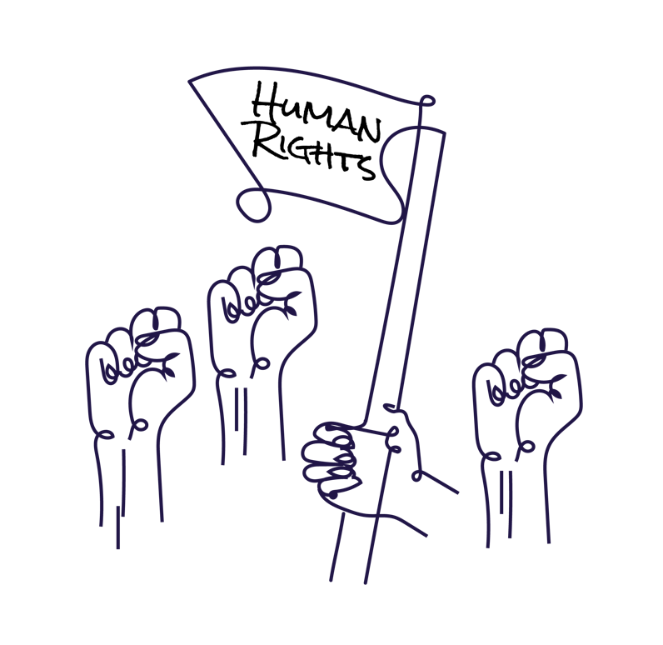

**Nothing about us without us**

1. https://www.unprpd.org/programme/ghana#:~:text=The%20latest%20population%20and%20housing,increase%20compared%20to%20previous%20data